Course Specialist Year 12 Test Four 2022

Student name: ________________ Teacher name: ________________

Task type: Response

Time allowed for this task: _____40______ mins

Number of questions: _____6______

Materials required: Upto 3 Calculators with CAS capability (to be provided by the student)

Standard items: Pens (blue/black preferred), pencils (including coloured), sharpener, correction fluid/tape, eraser, ruler, highlighters

Special items: Drawing instruments, templates, No notes allowed
A4 paper, and up to three calculators approved for use in the WACE examinations

Marks available: __40____ marks

Task weighting: _10___%

Formula sheet provided: Yes

Note: All part questions worth more than 2 marks require working to obtain full marks.

No notes allowed
No notes allowed

Q1 (5 marks) (4.1.6)

Determine the volume of the solid formed by rotating the area enclosed between about the y axis, as shown below.
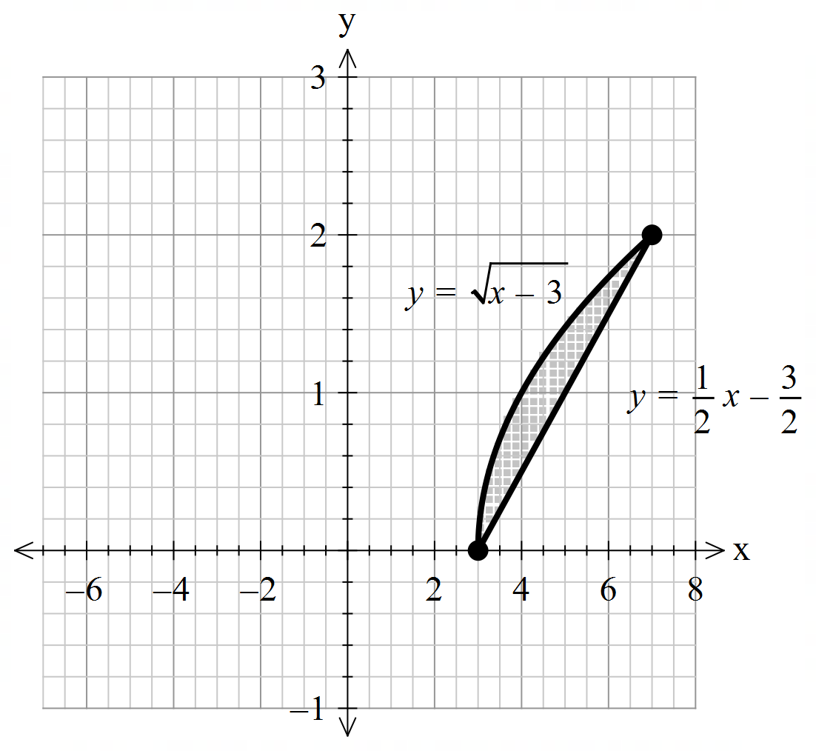

Q2 (5, 3 & 2= 10 marks) (4.1.4)
- By using integration and partial fractions, show how to derive from the differential equation () and is a constant.

Q2 continued
- Let equal the number of kangaroos living in a habitat after years and .
If initially there are kangaroos, determine the number in 10 years time.

- Determine the size of the population at the maximum growth rate.

Q3 (3, 2 & 3 = 8 marks) (4.2.5)
- Sketch the slope field on the axes below for

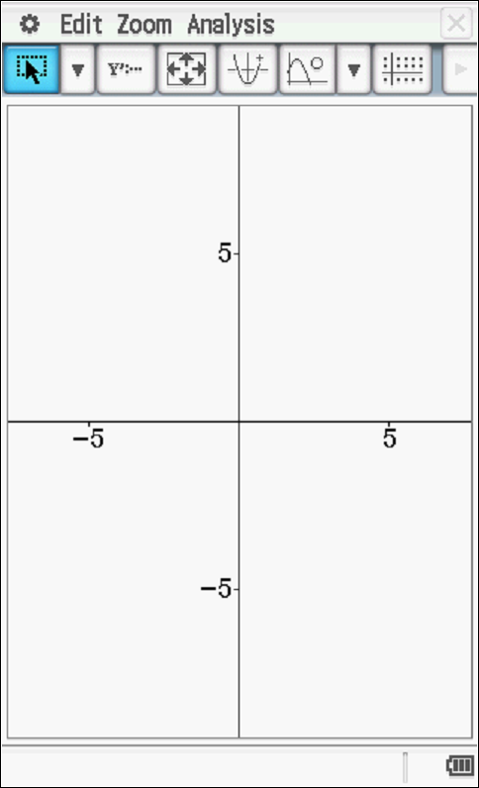

- Show the solution curve on the axes above that passes through point (2,2).

- Determine in cartesian form the solution curve for b above without using a classpad.
Hint – use logarithmic differentiation. Show all working.

Q4 (5 marks) (4.2.1)
Determine expressions in terms of only for in terms of only, using the following equation

Q5 (3 & 3 = 6 marks) (4.2.7)

Consider a particle that is moving with SHM such that with a maximum speed of 12 m/s.
- Determine the exact speed when the particle is half of an amplitude from the origin.

- Determine the percentage of the time that the particle is more than half an amplitude from the centre.

Q6 (4 & 2 = 6 marks) (4.2.7)
The motion of a bullet through a wall is modelled by the equation where is its acceleration and its velocity seconds after impact. Initially at impact the speed is 300 m/s and is at the origin (metres)

- Determine in terms of only.

Q6 continued-
- Determine how far the bullet penetrates the wall before coming to rest to the nearest mm.

